Information on tourist spots around Ojiya
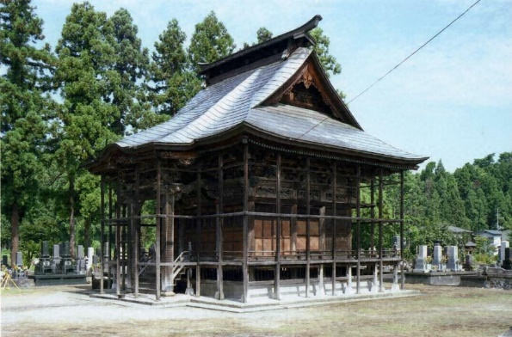
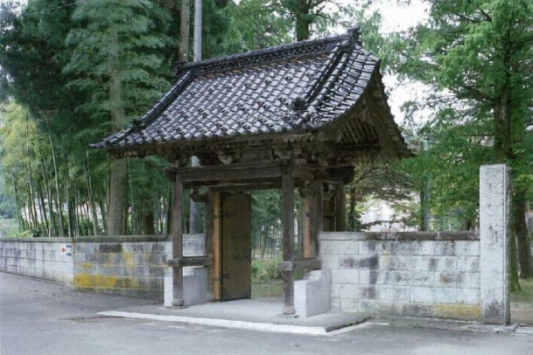

Chouonnji Temple

The gate of Chouonji Temple is constructed of four pillars with a gabled roof and it is detailed with carvings of whirlpools, young leaves and dots.

The gate is designated as a National Cultural Property. Judging by the carving style, it was most likely built in the late 18th century.

The Kannon-dō Hall has hip-and-gable roof which has a classy look and it is often used on castles. The architectural design called 'Mitesaki' is used to detail the hall; a kind of entablature used to construct and detail temples and shrines. In addition, those pillars and beams have carvings of sacred birds and animals. Inside the temple 12 Arhats are enshrined on “shumidan”; a platform which a Buddhist image is enshrined on. This hall is also designated as a National Cultural Property.

